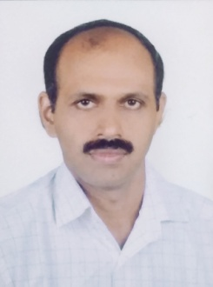

SREEKUMAR N V

Basic Personal Information

1 | Designation | : | Associate Professor
2 | Department | : | Statistics
3 | Mobile number | : | 9446271418
4 | Email id | : | nvsreekumar@gmail.com
5 | Qualification | : | M.Sc, Mphil, Ph .D
6 | Address for correspondence | : | DEPARTMENT OF STATISTICS, Government College for Women, Thiruvananthapuram
7 | Teaching Experience | : | 18 years

Research and Academic Contributions

BASIC RESEARCH DETAILS

1. | Current Areas of Research |  | : | Order Statistics, Reliability Analysis
2. | Whether Research Guide (Yes/No) |  | : | Yes
3. | Research Centre |  | : | Department of Statistics, University College, Thiruvananthapuram
4. | Affiliated University |  | : | University of Kerala
5. | Total No. of Publications | National | : | 5
 |  | International | : | 4

